EXPERIMENT-3

NAME:SHOBBIKA T ROLL NO:240701502

1.COMMAND LINE INTERFACE:

PYTHON CODE:

import os
import sys

def delete_file(filename):
try:
if not os.path.exists(filename):
print(f"Error: '{filename}' not found.")
return

os.remove(filename)
print(f"File '{filename}' deleted successfully.")

except Exception as e:
print(f"An error occurred: {e}")

if __name__ == "__main__":
if len(sys.argv) != 2:
print("Usage: python delete_file_cli.py <filename>")
else:
delete_file(sys.argv[1])

OUTPUT:
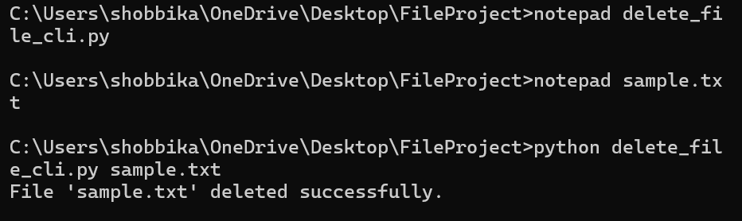

2.GRAPHICAL USER INTERFACE:

PYTHON CODE:

import tkinter as tk
from tkinter import messagebox
import os

def delete_file():
filename = filename_entry.get().strip()

if not filename:
messagebox.showwarning("Warning", "Please enter a filename!")
return

if not os.path.exists(filename):
messagebox.showerror("Error", f"File '{filename}' not found.")
return

confirm = messagebox.askyesno("Confirm", f"Are you sure you want to delete '{filename}'?")
if confirm:
try:
os.remove(filename)
messagebox.showinfo("Success", f"File '{filename}' deleted successfully.")
except Exception as e:
messagebox.showerror("Error", f"An error occurred: {e}")

# Create window
root = tk.Tk()
root.title("File Deleter")
root.geometry("400x150")
root.resizable(False, False)

tk.Label(root, text="Enter Filename:", font=("Arial", 11)).pack(pady=10)

filename_entry = tk.Entry(root, width=40)
filename_entry.pack()

tk.Button(root, text="Delete File", bg="red", fg="white",
font=("Arial", 10, "bold"),
command=delete_file).pack(pady=15)

root.mainloop()

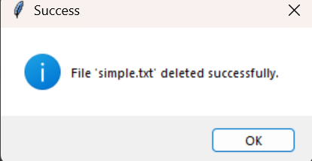
OUTPUT:
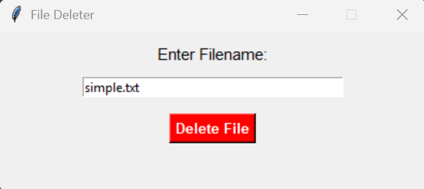
3.VOICE USER INTERFACE:

PYTHON CODE:

import speech_recognition as sr
import os

def delete_file_from_command(command):
words = command.lower().split()

if "delete" in words:
try:
file_index = words.index("delete") + 1
filename = words[file_index]

if not os.path.exists(filename):
print(f"Error: File '{filename}' not found.")
return

os.remove(filename)
print(f"File '{filename}' deleted successfully.")

except Exception as e:
print(f"Error: {e}")
else:
print("Say: 'Delete filename.txt'")

def listen():
recognizer = sr.Recognizer()
mic = sr.Microphone()

print("Listening... Say 'Delete filename.txt'")

with mic as source:
recognizer.adjust_for_ambient_noise(source)
audio = recognizer.listen(source)

try:
command = recognizer.recognize_google(audio)
print("You said:", command)
delete_file_from_command(command)

except sr.UnknownValueError:
print("Could not understand audio.")
except sr.RequestError:
print("Speech service unavailable.")

if __name__ == "__main__":
listen()

OUTPUT:

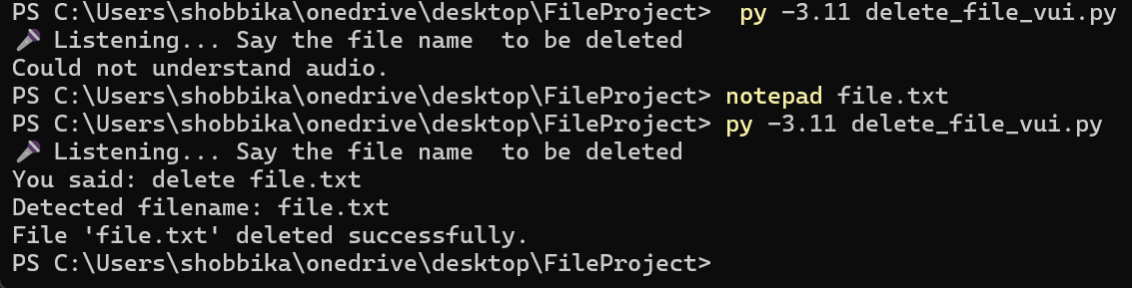

USER SATISFACTION:
def survey():
print("Rate your satisfaction (1-5):")

try:
cli = int(input("CLI (1-5): "))
gui = int(input("GUI (1-5): "))
vui = int(input("VUI (1-5): "))

if not all(1 <= x <= 5 for x in [cli, gui, vui]):
print("Enter ratings between 1 and 5 only.")
return

print("\nRatings:")
print("CLI:", cli)
print("GUI:", gui)
print("VUI:", vui)

average = (cli + gui + vui) / 3
print(f"\nAverage Satisfaction Score: {average:.2f}")

if average >= 4:
print("Users are highly satisfied.")
elif average >= 3:
print("Users are moderately satisfied.")
else:
print("Users are less satisfied.")

except ValueError:
print("Invalid input! Enter numbers only.")

if __name__ == "__main__":
survey()

